# Academic Writing

Academic writing is any type of assignment or documentation submitted for the completion of academic study with clear evidence. It is giving to students to measure the understanding about the subject matter. It is written on formal tone and style, not too complex for the readers. Different subject will have different type of conventions, vocabulary and types of discourse that need to be covered in those academic writing. However, there are some characteristics that are common around all of the types of academic writings (University of Leeds).

Characteristics of Academic writing:

* **Planned and focused**: The wording is planned to simplify the understanding of the subject to the readers.
* **Structured**: Materials and points are related to each other backing up the findings.
* **Formal in tone and style**: proper use of languages and tense, clear and appropriate use of grammar.

# Coursework and Dissertation

## Dissertation

A dissertation is a research project which requires a student to research on a particular topic of their choice and research independently. It requires the students to go through different past research papers, books, journals, surveys to gather data and evidence to support the final outcome of the dissertation. Students can ask for help and guidelines from the teacher which has similar field expertise on the topic of the dissertation (ECU 2019). Students can take separate courses to help boost their skills in the area of research.

## Coursework

A coursework requires the student to study a set of specified core units of the field that the student is trying to get a degree of. To complete a coursework the student has to attend a set of classes and reach minimum required hours to complete the course, complete given assignments, speaking tests and attend exams as required by the course. Some advanced coursework such as at master’s level might also require some minor thesis submission for the coursework completion (Paperwritingpro 2019). Similarly, “Coursework” can be defined as “Written or practical work done by a student during a course of study, usually assessed in order to count towards a final mark or grade” (*Planning Tank* 2019). As evidence there is no fixed global definition to the coursework though some of the basics are in common.

## History of Coursework and Dissertation

Dissertation and Coursework definition in medieval age were so different from how we define it today. In Medieval age, students were expected to have fluent knowledge of canonical text and age-old arguments of the scholastics. The typical dissertation would consist of “opponency, disputations and lectures”, all oral forms of test that would measure the student’s knowledge of their field. These knowledges would be presented by the students in their defense to their argument (Malone n.d.: 77).

# Writing Process

## Dissertation

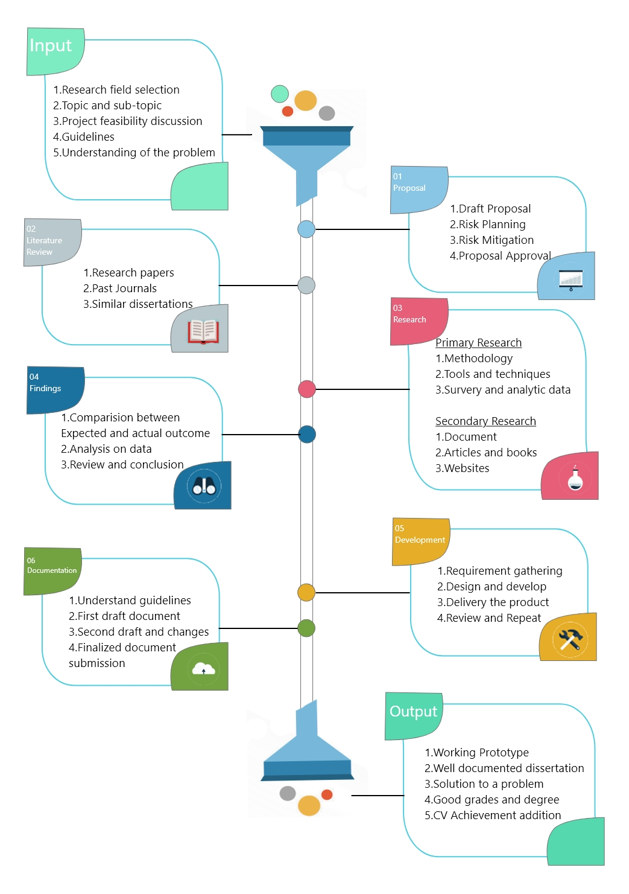

Figure 2:Writing Process for dissertation writing

## Coursework

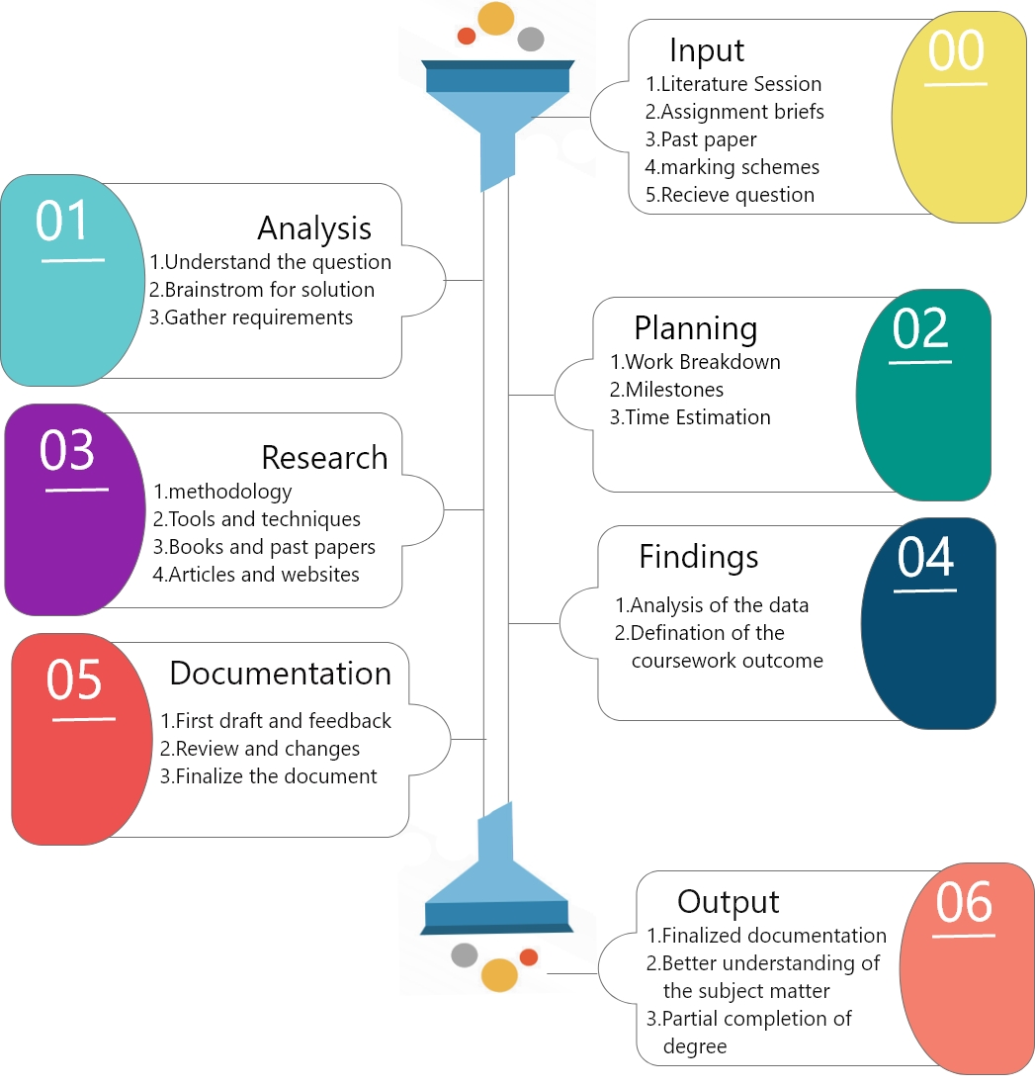

Figure 1:Writing Process for Coursework writing

## Compare and contrast of writing processes

Coursework has fixed structure and guidelines. For example, some college might have attendance requirement of 80% to complete the course some might have 70%. The guidelines are specific like what type of font to use, font size, color of the font, type of referencing, minimum book referencing, the structure of document i.e. What topic to put where, etc. But dissertation writing is not constraint by boundaries like that, the students are free to choose whatever font they seem fitting Structure of the document, Source of the data collection, etc. There is no proposal in coursework writing where as dissertation requires proposal to be approved for further processes. Research for the coursework is not thorough and is certain whereas dissertation requires thorough and iterative research gathering and analysis to draw conclusion.

# Similarities and Differences between Coursework and Dissertation

## Similarities

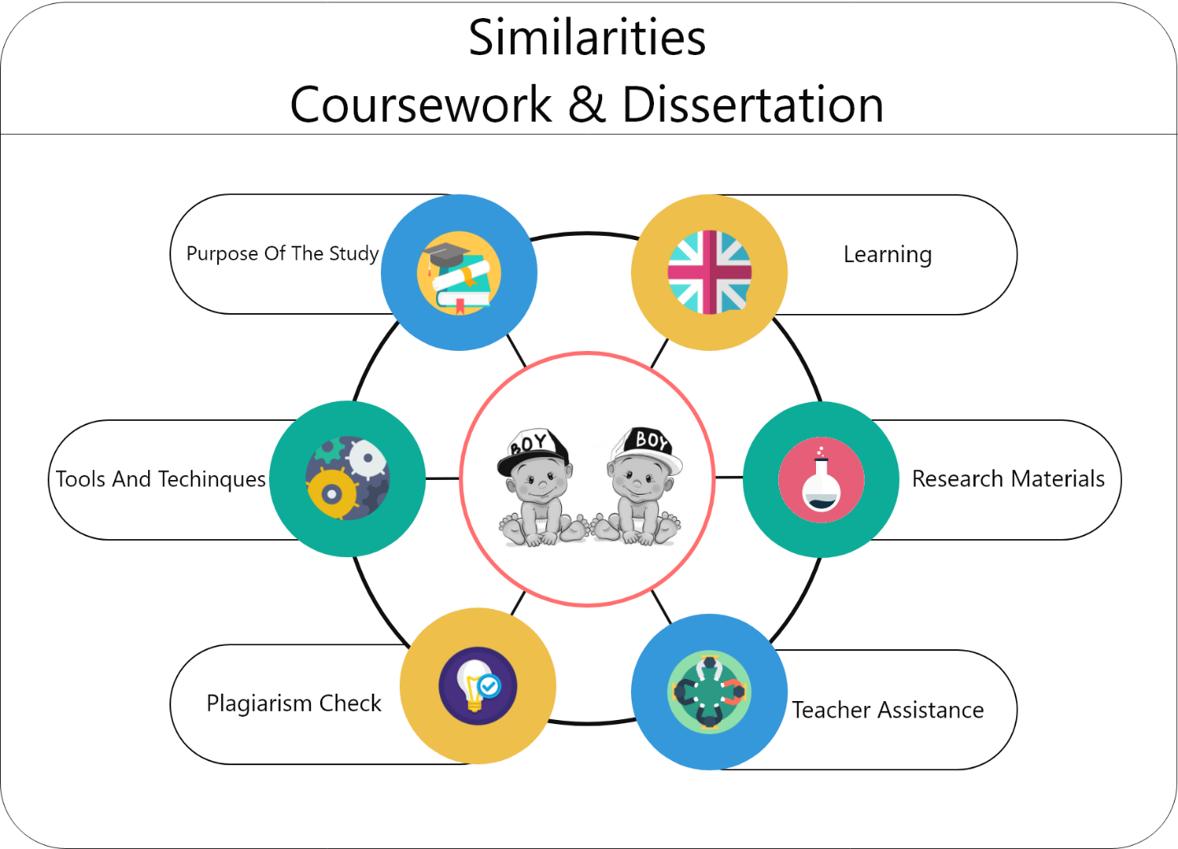

Figure 5:Similarities between coursework and Dissertation

* **Purpose of the study**: The coursework is only submitted as the requirement for the course completion and might not contribute later on the career path later but dissertation can be shown later on the career path downline as to show the research and study capabilities or skills of ones. But both are written as per completion of certain degree or course. Therefore, both dissertation and coursework contribute to the completion of the course.
* **Research materials**: Both dissertation and coursework require through research on the topic. The research type can be similar. Student can use all sorts of research materials to prove the outcome of the study. The research types can be:
* Empirical materials: This type of research requires students to go through different types of past scientific research papers, articles, books and journals which provide great share of information and collected data to prove the outcome of the study.
* Internet Sources: This type of research requires students to go through different type of online libraries and encyclopedia which are recognized by educational institutions. They are easy to find what you are looking for as you don’t have to sit hours reading and can search keywords to find the favorable topic of your choice (Planningtank 2018).
* **Learning**: Both dissertation and coursework provide a certain completion in fulfillment of degree and course. Dissertation itself marks transition from student to scholar and also contributes to future career. Both gives an opportunity to enhance students personal research skill, critical thinking capacity, agility in communication skills, Domain authorization and enhance the capability of creating and exchanging ideas (Gill 2018).
* **Teacher’s assistance**: Both coursework and dissertation are some sort of academic writing so if needed student can ask for supervisor’s assistance, feedback and review for better writing.
* **Plagiarism check**: Both coursework and dissertation are to be graded and so the student must be truthful about the source of data and present the originality of the contents of the writing. Both writings will be processed through plagiarism check to grade the research skills and originality of the contents of the writing.
* **Tools and techniques**: Though dissertation carry more weight than coursework both can be written similar tools and techniques. It can also be applied in data gathering. For e.g. MS word for documentation, similar graphical editing tools for image processing, similar fonts and styling, etc.

## Differences

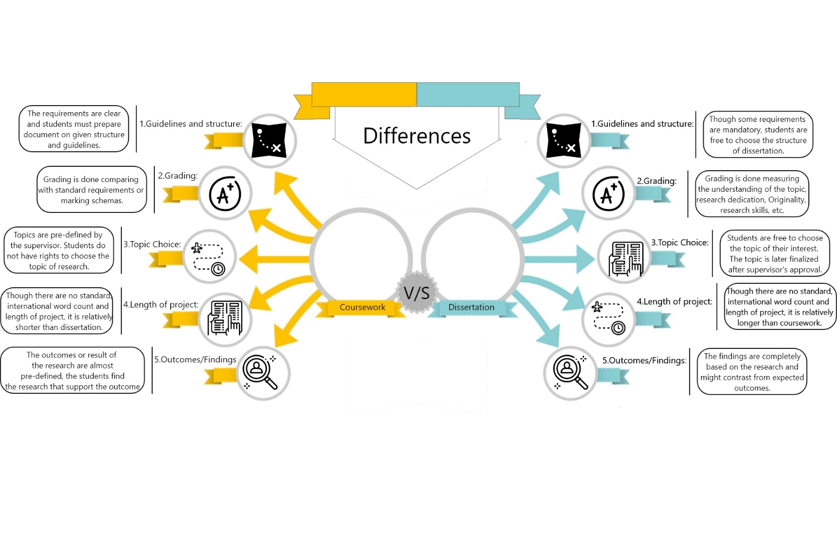

Figure 4:Differences between coursework and dissertation

* **Grading**: Coursework has a certain type of guidelines as to how the papers are to be written and what to include in the papers. The originality, research and the contents are matched with the marking guidelines and upon the matching of the marking guidelines the grading is done by the teacher or supervisor. Whereas, dissertation does not have fixed guidelines and marking schemes prep-defined. Of course, there are certain parts or structure of the documentation but the students are free to add extra elements as they seem fit upon the supervision of the mentor. So, the grading is defined by the quality of the content, originality, the dedication on research, personal understanding and research skills of the students.
* **Topic choice**: Coursework requires students to do research on the topic given by the teacher or supervisor to know the understanding of the student on the core unit of the undertaken course. Whereas dissertation writing is different it requires student to choose the topic of their choice and it is to know the research skills, understanding and expertise of the student on the topic.
* **Length of the project**: Coursework are partial fulfillment of the course so generally the length of the coursework is relatively shorter and requires less dedication than the dissertation as it is only to fulfill the criteria to complete the course. Usually the length of the coursework is about 1350-1650-word count or 10-12 pages of documentation (The University of Auckland 2018).

In the contrary Pearson a British education publishing and assessment servicing company defines the word count to be of 3000-4000 (A level History coursework word count guidance n.d.). In any case the word count of the coursework seems to vary from subject to subject and foundation to foundation, however common thing is that the word limit is +-10% of the given word count guideline.

Dissertation is completely on another level it requires a lot of dedication as it can also determine the career of individual. The time-length of the dissertation is determined by the weight of the degree for which it is being submitted for. Dissertation are relatively larger in word count it might range form 10,000- 12,000-word count or 50 pages of documentation (Anon 2016). On the contrary, Lantsoght argues that the average word count for the dissertation is 10,000 on average(PhDTalk 2018). As evidence there is also no fixed word count for dissertation as well. The word count varies from the course and foundation.

* **Outcomes/ Findings**: Generally, the coursework has a pre-defined outcome and you have to research to prove the given outcome. For example, the coursework title can be “AI will control the world in the future prove it”. So, the coursework is generally providing the evidences and research data to prove the given point. Whereas the dissertation does not have a fixed outcome, you choose a topic and collect the research data then the outcome might or might not be expected. For example, dissertation title can be “Is digital learning better than traditional learning?” here after collecting the data and upon analysis they outcome can go both ways whether it might be “yes” or “no” you have to show honest result without and bias.

# Benefits and challenges of Coursework and Dissertation

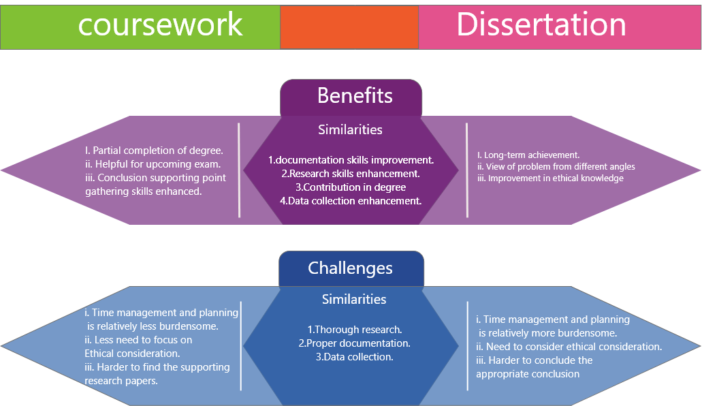

Figure 3:Benefits and challenges of Coursework and Dissertation

## Benefits

### Similarities

Both coursework and dissertation are beneficial to the writers in some way. Some similarities between the benefits of writing them are documentation skills improvement, Research skills enhancement, Contribution in degree, Data collection skill enhancement, etc.

### Differences

Though both are beneficial some of the benefits can be differentiated. Dissertation provides long-term achievement where student can show their research in their CV while coursework is only a research paper submitted to pass out may be a semester. Coursework gives students a way to get better understanding of the subject matter and might be helpful for upcoming exams while dissertation increases one’s viewing angle on the problem and to come at better conclusion. Coursework enhances one’s ability to find supporting evidence to an outcome on the contrary dissertation enhances one’s view and ethical consideration on the subject matter (Anderson 2017)

## Challenges

### Similarities

Writing a research paper requires a lot of hard work and dedication. Some of the similar challenges on writing coursework and dissertation are:

* **Thorough research**: One requires to dedicated a lot of time in researching the subject so that the outcome is accurate.
* **Proper documentation**: A proper documentation contains proper use of grammar, tense, style, structuring which is hard to achieve.
* **Data collection**: The data needed for the research need to be genuine and gathering genuine and relatable data is time consuming.

### Differences

Due to difference in weight there are some challenges that can be categorized individually. Time management and planning is relatively more time consuming and harder in case of dissertation than that in coursework. While writing dissertation one has to take ethical consideration into account whereas while writing coursework it is not necessary as you are just simply showing data of other resources as evidence. In case of coursework it is harder to gather supporting and relevant data whereas dissertation requires deep thinking and hard to draw appropriate conclusion (Planningtank 2018).

# Conclusion

Thus, we can conclude that academic writing helps students understand the subject topic more whatever it might be. Both coursework and dissertation provide students to enhance their problem understanding and solving solution so academic writing is a good trait for student to learn to solve problem and understand the subject topic more.